**Pendulum Moment of Inertia**

**Topics Covered**

• Finding moment of inertia analytically and experimentally.

**Prerequisites**

• Integration laboratory experiment.

• Rotary pendulum module is attached to the QUBE-Servo 2.

**1 Background**

The free-body diagram of the QUBE-Servo 2 pendulum system is shown in Figure 1.1.

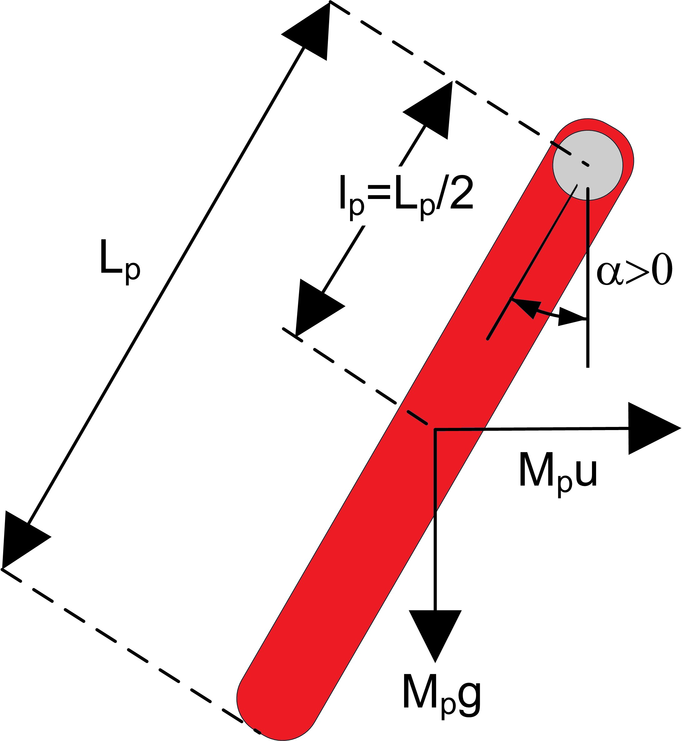

Figure 1.1: Free-body diagram of pendulum

From the free-body diagram in Figure 1.1, the resulting nonlinear equation of motion of the pendulum is

*J α*¨(*t*) = *M g Lp* sin (*α*(*t*))*,* (1.1)

*p p* 2

where *Jp* is the moment of inertia of the pendulum at the pivot axis, *Mp* is the total mass of the pendulum assembly, and *Lp* is the length of the pendulum (from pivot to end). The center of mass position is at *Lp* /2, as depicted in Figure 1.1.

The moment of inertia of the pendulum can be found experimentally. Assuming the pendulum is not actuated, linearizing Equation 1.1 and solving for the differential equation yields

*J* = *Mp glp ,* (1.2)

*p* (2*πf* )2

where *f* is the measured frequency of the pendulum as the arm remains rigid. The frequency is calculated using

*ncyc*

*f* = (1.3)

∆*t*

where *ncyc* is the number of cycles and ∆*t* is the duration of these cycles. Alternatively, *Jp* can be calculated using the moment of inertia expression

∫

*J* = *r*2 *dm,* (1.4)

where *r* is the perpendicular distance between the element mass *dm* and the axis of rotation.

**2 In-Lab Exercises**

Based on the model already designed in Integration laboratory experiment, design a model that measures the pendulum angle using the encoder as shown in Figure 2.1.

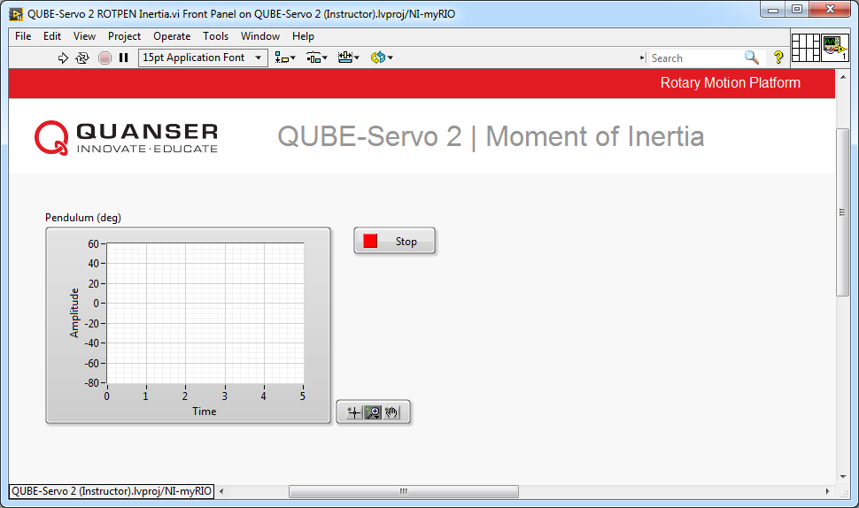

(a) Front Panel

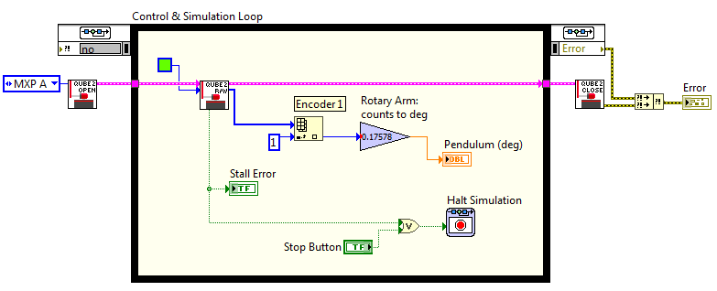

(b) Block Diagram

Figure 2.1: Displays measured pendulum angle

1. Find the moment of inertia acting about the pendulum pivot using the free-body diagram. Make sure you evaluate it numerically using the parameters defined in the QUBE-Servo 2 User Manual.

**Hint:** For solid objects with a uniform density, you can express the differential mass in terms of differential length.

2. Build the VI shown in Figure 2.1. Enter the value of 0*.*17578 (equivalent to 360/(4 *×* 512)) in the encoder sensor gain to measure the angular displacement of the pendulum in degrees.

3. Run the VI. With the controller running, manually perturb the pendulum while holding the rotary arm in place.

The scope response should be similar to Figure 2.2.

4. Find the frequency and moment of inertia of the pendulum using the observed results. If needed, use the

*Graph* palette to zoom on the response.

5. Compare the moment of inertia calculated analytically in Exercise 1 and the moment of inertia found experimentally. Is there a large discrepancy between them?

6. Click on the Stop button to stop the VI.

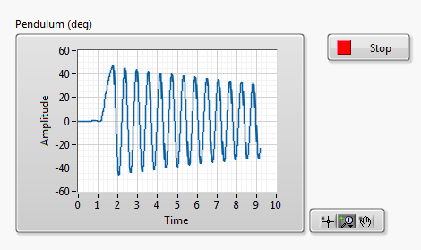

Figure 2.2: Free-oscillation response of pendulum

© 2017 Quanser Inc., All rights reserved.

Quanser Inc.

119 Spy Court Markham, Ontario L3R 5H6

Canada [info@quanser.com](mailto:info@quanser.com) Phone: 1-905-940-3575

Fax: 1-905-940-3576

Printed in Markham, Ontario.

For more information on the solutions Quanser Inc. offers, please visit the web site at:

[http://www.quanser.com](http://www.quanser.com/)

This document and the software described in it are provided subject to a license agreement. Neither the software nor this document may be used or copied except as specified under the terms of that license agreement. Quanser Inc. grants the following rights: a) The right to reproduce the work, to incorporate the work into one or more collections, and to reproduce the work as incorporated in the collections, b) to create and reproduce adaptations provided reasonable steps are taken to clearly identify the changes that were made to the original work, c) to distribute and publically perform the work including as incorporated in collections, and d) to distribute and publicly perform adaptations. The above rights may be exercised in all media and formats whether now known or hereafter devised. These rights are granted subject to and limited by the following restrictions: a) You may not exercise any of the rights granted to You in above in any manner that is primarily intended for or directed toward commercial advantage or private monetary compensation, and b) You must keep intact all copyright notices for the Work and provide the name Quanser Inc. for attribution. These restrictions may not be waved without express prior written permission of Quanser Inc.